**Object detection using YOLO and Pretrained Model**

**Introduction to Object Detection**

Object detection is a computer vision task that involves identifying and locating objects within images or videos. It not only classifies the objects present but also provides bounding boxes around them. One of the most popular and efficient algorithms for object detection is **You Only Look Once (YOLO)**. YOLO has gained traction due to its speed and accuracy, making it suitable for real-time applications. In this write-up, we will discuss the theory behind YOLO, how to implement it using pretrained models, and its advantages and disadvantages.

**Theory of YOLO (You Only Look Once)**

YOLO is a deep learning-based approach that divides an image into a grid and predicts bounding boxes and class probabilities for each grid cell. The key features of YOLO include:

1. **Single Neural Network**: Unlike traditional object detection methods that apply region proposal networks and then classify the regions, YOLO treats object detection as a single regression problem. It predicts bounding boxes and class probabilities directly from full images in one evaluation.
2. **Grid System**: The image is divided into an S×SS \times SS×S grid. Each grid cell is responsible for predicting bounding boxes and class probabilities for objects whose center falls within the cell. For each bounding box, the model predicts:
   * Coordinates of the box (x, y, width, height).
   * Confidence score indicating the probability that the box contains an object and how accurate the box is.
   * Class probabilities for the object detected.
3. **Speed**: YOLO is designed for real-time object detection. Its single-pass architecture allows it to run at high speeds, making it suitable for applications like video surveillance and autonomous vehicles.
4. **Architecture**: The YOLO architecture has undergone several iterations, with versions like YOLOv2, YOLOv3, and the latest YOLOv4 and YOLOv5 improving accuracy, speed, and efficiency.

**Steps to Implement YOLO Using Pretrained Models**

Implementing object detection with YOLO using pretrained models involves the following steps:

1. **Setup the Environment**:
   * Install necessary libraries like TensorFlow, Keras, OpenCV, and any other dependencies required for YOLO.
   * Clone the YOLO repository from GitHub if you are using a specific implementation.
2. **Download Pretrained Weights**:
   * Obtain pretrained weights for YOLO from the official YOLO website or the respective GitHub repository. These weights are usually trained on the COCO dataset, which contains various object classes.
3. **Load the YOLO Model**:
   * Load the YOLO model with the configuration file and the weights. This step involves reading the network architecture and weights into your program.
4. **Image Preprocessing**:
   * Prepare the input image by resizing it to the size expected by the YOLO model (usually 416x416 or 608x608 pixels). Normalize the pixel values and convert the image into a format suitable for model input.
5. **Object Detection**:
   * Run the model on the input image. The model will output bounding box coordinates, confidence scores, and class probabilities for detected objects.
   * Apply a threshold to filter out weak predictions based on confidence scores.
6. **Post-Processing**:
   * Use non-maximum suppression (NMS) to eliminate redundant bounding boxes for the same object, keeping only the best ones based on confidence scores.
   * Draw bounding boxes and labels on the original image to visualize the detected objects.
7. **Display or Save Results**:
   * Show the output image with detected objects in a window or save it to a file for further analysis.

**Advantages of YOLO**

1. **Real-Time Detection**: YOLO is one of the fastest object detection models, allowing for real-time processing, which is crucial for applications like autonomous driving and surveillance.
2. **Global Context**: Since YOLO looks at the entire image during detection, it can better understand the context and relationships between objects, leading to more accurate predictions.
3. **Single Network**: YOLO's architecture is simpler compared to multi-stage detection systems, making it easier to implement and optimize.
4. **Good Generalization**: Pretrained YOLO models can generalize well to new datasets, making it easier to adapt them for specific applications without needing extensive training.

**Disadvantages of YOLO**

1. **Localization Errors**: YOLO may struggle with accurately localizing small objects or objects that are close together due to its grid-based approach, which can lead to overlapping bounding boxes.
2. **Class Imbalance**: The performance of YOLO can degrade in cases of class imbalance, where some object classes are underrepresented in the training data.
3. **Fixed Input Size**: YOLO requires a fixed input size for the model, which may lead to loss of information if the aspect ratio of the input image is not maintained.
4. **Less Accurate for Small Objects**: While YOLO is fast, it may not be as accurate as other models (like Faster R-CNN) for detecting small objects or objects that are partially occluded.

**Applications of YOLO**

1. **Autonomous Vehicles**: YOLO is used in self-driving cars for detecting pedestrians, other vehicles, traffic signs, and obstacles in real-time.
2. **Surveillance**: Security systems employ YOLO for detecting intruders or monitoring activity in restricted areas through camera feeds.
3. **Retail Analytics**: Retailers use YOLO to analyze customer behavior, track foot traffic, and monitor inventory levels by detecting products on shelves.
4. **Healthcare**: YOLO can assist in medical imaging for identifying anomalies or specific features in X-rays, MRIs, and CT scans.
5. **Robotics**: Robots use YOLO for navigation and object recognition in dynamic environments, enhancing their ability to interact with objects and people.

**Diagram**

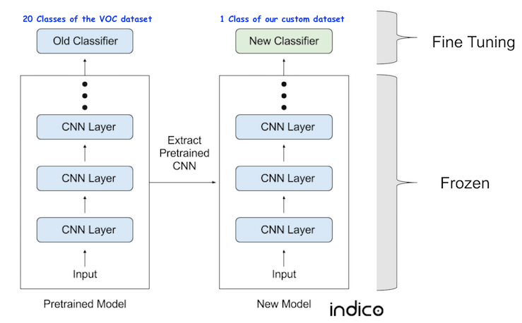**10.**

**Conclusion**

Object detection using YOLO and pretrained models provides a powerful solution for identifying and localizing objects in images and video streams. YOLO’s speed and efficiency make it suitable for real-time applications, while pretrained models enhance accuracy and reduce training time. Despite some limitations, YOLO remains a popular choice in the field of computer vision for a wide range of applications.